Lab for Ansible

1) Create 3 Ec2 machine name them as : Ansibleserver

Node1 and node2

**(DO NOT USE AMAZON LINUX 2023 AMI …USE AMAZON LINUX 2 AMI then only this lab will work)**

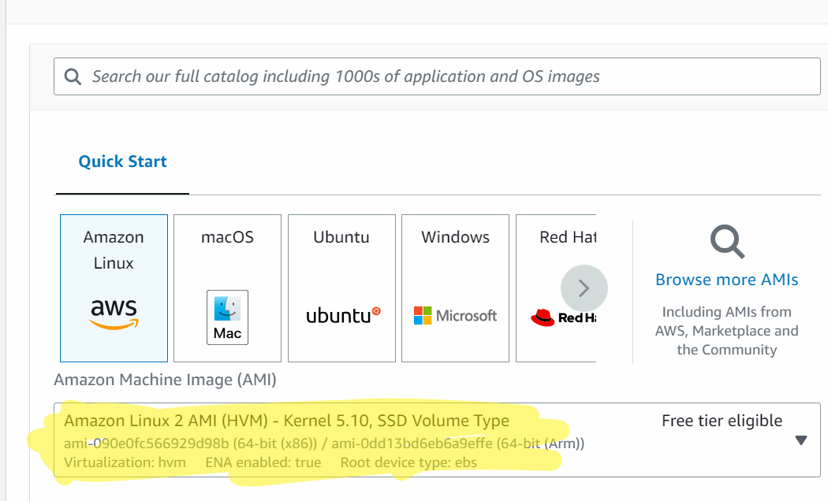

2) get inside the machine

3) **In Ansible machine/ansible server only :**

sudo su

yum install <https://dl.fedoraproject.org/pub/epel/epel-release-latest-7.noarch.rpm>

yum update -y

yum install git python python-level python-pip openssl ansible -y

ansible --version

vi /etc/ansible/hosts

press i

## Add the below content in the hosts file…make sure you copy paste the correct ip

[demo]

private ip of the machine1

private ip of the machine2

press esc :wq

vi /etc/ansible/ansible.cfg

press i

Remove # from inventory (line 14)

Remove # from sudo-user (line 22)

esc and :wq

4) >>>>>>>do this step in all the nodes and ansible machine <<<<<<<

adduser ansible

# create a user with the name ansible

passwd ansible

#setting up the password for the user ansible

(now set the password)

## Now we need to provide the authentication rights to the ansible user. So that the ansible user can perform sudo commands …

visudo

press i

scroll down and find #All root to run any command ....

now there add

ansible ALL=(ALL) NOPASSWD:ALL (Add this below root)

(line number: 101)

5) **Do this step in ansible server only:**

su - ansible

*## su ansible means that you want to login as ansible user*

sudo yum install httpd -y

*# we are checking that are we able to install a software httpd via ansible user*

sudo yum remove httpd -y

exit

#*exit will exit from the ansible user*

6) **Do this step in ansible and node servers**

vi /etc/ssh/sshd_config

press i

in authentication,

uncomment Permit root login yes

(remove #) (line number 38)

scroll down and uncomment password authentication yes(by removing #) (line61)

and comment password authentication no

(by putting #)(line 63)

7) **do this for nodes and ansible server**

service sshd restart

8)**In ansible server**:

##*Login as a ansible user*

su - ansible

#*# Trying to connect with node1 . you can copy paste the private ip of node1 from aws management console*

ssh <<private ip of node1>>

touch fileinnode1 file1innode1

exit

**Now go to node 1**

su - ansible

ls

check if fileinnode1 and file1innode1 is there

Again come back to ansible server

su - ansible

ssh <<private ip of node2>>

touch fileinnode2 file1innode2

exit

**Now go to node 2**

su - ansible

ls

check if fileinnode2 and file1innode2 is there

###########################REMOVE PASSWORD AUTHENTICATION USING TRUST RELATIONSHIP#########################

9) Go to ansible server (you need to ensure that you are logged in as ansible user)

ssh-keygen (press enter - enter - enter)

ls -a

cd .ssh/

ls

ssh-copy-id ansible@<<private ip of node1>>

password : last time it will ask for pass

ssh-copy-id ansible@<<private ip of node2>>

password : last time it will ask for pass

cd ..

ssh <<private ip of node1>>

exit

ssh <<private ip of node 2>>

exit

##########################################HOST PATTERN###########################################

10) Do this in ansible machine

ansible all --list-hosts

ansible demo --list-hosts

#show me the hosts within the demo group

################################################ADHOC COMMANDS ########################################

11) Go to ansible server

ansible demo -a "ls"

ansible all -a "touch fileinallnodes"

ansible demo -a "sudo yum install httpd -y"